1 Calculate the average speed (in m/s) of (change time to secs)
Formulas
Speed v=d/t
Distance d=v x t
a A person who runs 550 metres in 2 minutes
v=
t=
d=

b Calculate the average speed (in m/s) of (change time to secs and km to m)
A car that goes 42 kilometres in 6.5 minutes.
v=
d=
t=

CHANGE INTO CORRECT UNITS TO SOLVE (convert m/s to km/hr then use d=v x t)
2 Calculate the distance travelled by:
a A rocket moving away from the Earth at a speed of 1527m/s for 12hours in km.
d=
v=
t=

CHANGE INTO CORRECT UNITS TO SOLVE (convert mins to sec then use d=v x t)
b The distance travelled by a boy, after walking at a speed of 4.2 m/s for 48 minutes.
d=
v=
t=

3 The car slows from 50 km/h to 20 km/h when entering the school zone.
a Calculate the conversion of these speeds from km/h to m/s.

b Given that this change of speed occurred over 12 seconds, calculate the average deceleration of the car

4 Mum exerts a force of 500 N on a 10kg shopping trolley.
The trolley accelerates at 5 m/s².

a Friction acts between the trolley and the floor. Calculate the size of the friction force acting on the trolley.

b Demonstrate where this force acts by drawing a diagram and marking in the force arrows

5 A truck starts moving when a traffic light changes green. The table below shows its speed each second.

Time (s) | Speed (m/s)
0 | 0
1 | 3
2 | 9
3 | 15
4 | 20
5 | 20

Calculate the truck’s:
a acceleration during the first 2 s

b average acceleration for the whole 5 s.

6 Using the speed–time graph shown below, calculate the:

  - distance travelled in the first 4 seconds. (2)

  - total distance travelled (2)

.
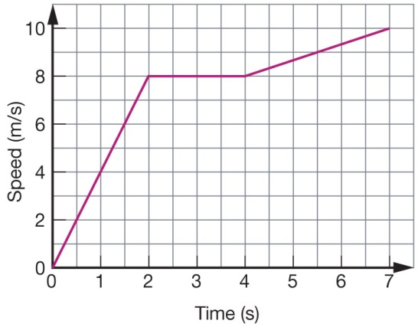

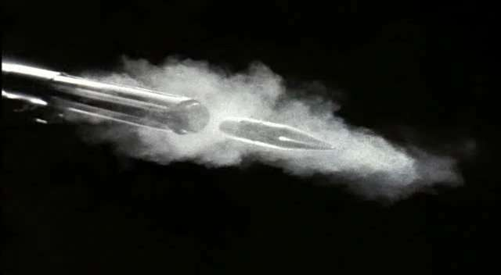
7 Calculate the kinetic energy of a ball of mass 250 g that leaves a bat with a speed of 150 m/s.

8 Calculate the work done when:
a a force of 60 N moves an object a distance of 5 metres

b How much work would be done if a bag is too heavy for a student to lift?

9 A weight with a mass 15 kg is dropped from a height of 60 metres off a cliff.
Calculate:
a the potential energy of the weight before it was dropped. (Assume gravitational field strength is 9.8 N/kg.)

b the speed of the weight as it reaches the ground. (Assume that all the potential energy of the object is converted to kinetic energy.).
Hint: You will need to use E_{k} = ½ ms²

10 Mihi walks east for 3 km, stops for a break, and then runs the same direction for 4 km before she stops.
What distance did she move?
What is her displacement?

- Cameron rides his bicycle 20 km north, turns around, and then rides the bicycle 15 km back toward his starting point.
What distance did he move?
What is his displacement?

12. How much work does your bedroom lamp (containing a 100 W light-bulb) do every evening when you read for half an hour before you go to bed at 9:45pm?

13. How much work is done pulling a fully laden sled with a force of 150N for 15 seconds over 3m?

- 14 Bob rides his bike for 2 hours and travels 40km. What was his average speed?

15 Jen runs a marathon, a 42km long distance race. It takes her 4 hours. What was her average speed?

16 Geoff rides his motorbike from his house to his girlfriend’s house. It takes him 2 hours. His girlfriend lives 300km away. The police accuse Geoff of speeding. Was Geoff speeding?

17 It will take 3000 Joules of energy to push a large moving box up a ramp and into the back of a truck. If the length of the ramp is 15 meters, how much force will be required for Tom accomplish this task?

SOLUTIONS

Year 10 General Physics Mid Topic Test Revision Name:____________________

1 ` Calculate the average speed (in m/s) of
a A horse that who runs 920 metres in 6.5 minutes
s=? s=d/t
d=920 920/390
t=6.5 x 60 5.36ms

b A bike that goes 20 kilometres in 5.25 minutes.
S=? s=d/t
d=20000 20000/315
t=5.25x60=315 63.49ms

2 Calculate the distance travelled by:
a A rocket moving away from the Earth at a speed of 2000 m/s for one day in km
s=2000 d=sxt
d=? 2000x86400
t=24x60x60=86400 d=172800000m
d=172800km

b A boy, after walking at a speed of 2 m/s for 50 minutes.
S=2 d=sxt
T=50x60=3000 2x3000
D=? 6000m

3 The car slows from 50 km/h to 20 km/h when entering the school zone.
a Calculate the conversion of these speeds from km/h to m/s.
50km/hr /60 /60 x 1000 = 13.8m/s
20km/hr = 5.55m/s

b Given that this change of speed occurred over 12 seconds, calculate the average deceleration of the car
a=? a=(v-u)/t
v=5.55 -6.87ms
u=13.8
t=12

4 Mum exerts a force of 500 N on a 10kg shopping trolley.
The trolley accelerates at 5 m/s².

a Friction acts between the trolley and the floor. Calculate the size of the friction force acting on the trolley.

F=m x a 10 x 5 = 50
m=10 Trolley should only require 50N of force
a=5 Other 450N is due to friction

b Demonstrate where this force acts by drawing a diagram and marking in the force arrows

5 A truck starts moving when a traffic light changes green. The table below shows its speed each second.
Time (s) | Speed (m/s)
0 | 0
1 | 3
2 | 9
3 | 15
4 | 20
5 | 20
Calculate the truck’s:
a acceleration during the first 2 s
a=? a=(v-u)/t
v=9 (9-0)/2
u=0 a=4.5ms2
t=2

b average acceleration for the whole 5 s.
a=? a=(v-u)/t
v=20 (20-0)/5
u=0 a=4ms2
t=5

6 Using the speed–time graph shown below, calculate the:

  - distance travelled in the first 4 seconds. (2)

4+8+8+8=28

  - total distance travelled (2)
28+8.5+9.5+10 = 56m
.

7 Calculate the kinetic energy of a ball of mass 250 g that leaves a bat with a speed of 150 m/s.
Ek=1/2mv²
M=0.25 0.5x0.25x150²
V=150 E_{k}=2812.5J

8 Calculate the work done when:
a a force of 60 N moves an object a distance of 5 metres
w=fxd 60 x 5
F=60N w = 300J
D=5m

b How much work would be done if a bag is too heavy for a student to lift? 0

9 A weight with a mass 15 kg is dropped from a height of 60 metres off a cliff.
Calculate:
a the potential energy of the weight before it was dropped. (Assume gravitational field strength is 9.8 N/kg.)
E_{p}=mgh 15 x 9.5 x 60
M=15 8820J
G=9.8
H=60

b the speed of the weight as it reaches the ground. (Assume that all the potential energy of the object is converted to kinetic energy.).
Hint: You will need to use E_{k} = ½ ms²
E_{k}=8820 8820 = 0.5 x 15 x s²
M=15 (8820 x 2) /15 =s²
S=? s = 514.39ms

10 Mihi walks east for 3 km, stops for a break, and then runs the same direction for 4 km before she stops.
What distance did she move? 7km
What is her displacement? 7km East

- Cameron rides his bicycle 20 km north, turns around, and then rides the bicycle 15 km back toward his starting point.
What distance did he move? 35km
What is his displacement? 5km North

12. How much work does your bedroom lamp (containing a 100 W light-bulb) do every evening when you read for half an hour before you go to bed at 9:45pm?

13. How much work is done pulling a fully laden sled with a force of 150N for 15 seconds over 3m?

- 14 Bob rides his bike for 2 hours and travels 40km. What was his average speed?

15 Jen runs a marathon, a 42km long distance race. It takes her 4 hours. What was her average speed?

16 Geoff rides his motorbike from his house to his girlfriend’s house. It takes him 2 hours. His girlfriend lives 300km away. The police accuse Geoff of speeding. Was Geoff speeding?

17 It will take 3000 Joules of energy to push a large moving box up a ramp and into the back of a truck. If the length of the ramp is 15 meters, how much force will be required for Tom accomplish this task?

